Russian weekly grain, end of week report, May 9-10, 2025
IKAR
Not for reproduction and redistribution. It is our policy that RWG and its parts are NOT distributed and NOT meant to ANY government body or agency. Thank you for your understanding and cooperation

This report is still of interim nature, as during holidays our markets remain mostly non-functional.
***

Hot topics and headlines

IKAR slightly elevates its 2024/25 wheat export forecast from previous 40 to 41 mmt, (w/o direct export from new territories) and lowers carry-outs. See our fresh domestic S&Ds…
***
Our closest forward FOB Black Sea 12.5% wheat price index is seen at $247 per ton, 11.5% is seen at $241. Once again to stress: the demand is concentrated in a narrow strip of Egypt and neighboring countries…
***
New crop pricing is unclear yet. We see the range between bids and offers between 226 ans $235 per ton, but Russians are unlikely to be active sellers even at $235 up until some more clearance with the crop size, ruble exchange rate, and export (duty and not only) regime...
***
FOB Azov 12.5% is seen at about $234 per ton, 13.5% at $244, 14.5% at $254.
***
Interesting figures: in July – April 2024/25 Russian railroad grain shipments to Kazakhstan are 532 tmt (incl. 231 tmt in past July) in comparison with 1871 tmt during the same period of 2023/24. In turn, Kazakhs’ grain shipments to Russia and via Russia (the latter is predominant, of course) are seen at 1120 tmt in comparison with 667 tmt in the past season…
***
During May holidays winter wheat and other small grains across European Russia have gained a lot due to very beneficial weather: strong or good precipitation almost everywhere in combination with cool weather. In Rostov surface and subsoil moisture finally “met each other”. Now for South of Russia the biggest remaining risk is seen in notorious “sukhovey”, or “Astrakhanets”: extremely hot and dry wind coming from Caspian Sea semi-desert/Middle Asia.

Anyway, if such weather persist w/o “adventures” we could further elevate our official domestic wheat production forecast…

Meanwhile thermophilic crops are in need of higher temps…
***

Hot topic 1. Fresh domestic S&Ds

Hot topic 2. Export pace. Final April wheat export (w/o direct shipments from new regions) is above 2.3 mmt: due to higher, than expected railway export shipments.

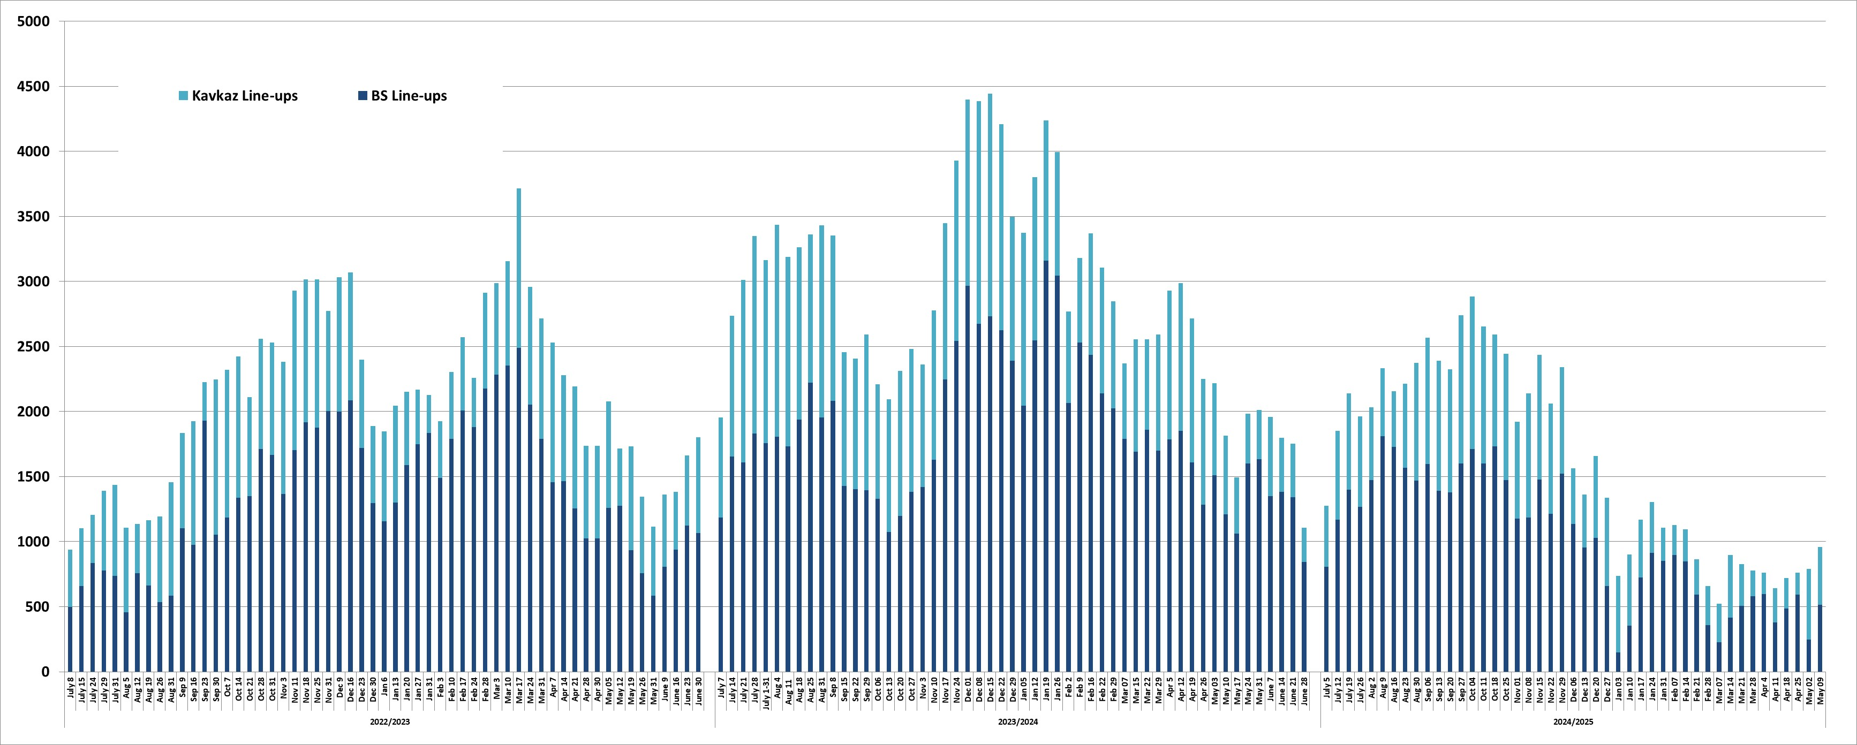

Russian grain export accrdng to ports and railway shipments data, tmt
 | Wheat |  |  |  |  | Barley |  |  |  |  | Corn |  |  |  |  | All grains+ зернобобовые ( по ВЭД)
 | 2022/ 23 | 2023/24 | 2024/25 |  |  | 2022/ 23 | 2023/24 | 2024/25 |  |  | 2022/ 23 | 2023/24 | 2024/25 |  |  | 2022/ 23 | 2023/24 | 2024/25
 |  |  | Ports | In-land | Total |  |  | Ports | In-land | Total |  |  | Ports | In-land | Total |  |  | Ports | In-land | Total
July* | 2209 | 4133 | 3187 | 460 | 3647 | 262 | 1201 | 918 | 83 | 1001 | 247 | 547 | 321 | 4 | 325 | 2802 | 6166 | 4570 | 581 | 5152
August | 3769 | 5367 | 5224 | 401 | 5625 | 804 | 1177 | 558 | 45 | 603 | 141 | 276 | 271 | 3 | 274 | 4870 | 7162 | 6185 | 489 | 6674
September | 4138 | 5345 | 5008 | 440 | 5449 | 701 | 999 | 641 | 88 | 729 | 40 | 281 | 236 | 2 | 238 | 5145 | 7508 | 6144 | 596 | 6741
October | 4719 | 5049 | 5391 | 457 | 5848 | 626 | 545 | 496 | 99 | 595 | 91 | 595 | 344 | 1 | 344 | 5666 | 6729 | 6686 | 646 | 7331
November | 4804 | 3397 | 4021 | 442 | 4463 | 581 | 395 | 324 | 75 | 399 | 232 | 640 | 393 | 2 | 395 | 5802 | 4792 | 4902 | 573 | 5475
December | 4477 | 3865 | 3628 | 251 | 3879 | 371 | 363 | 129 | 51 | 180 | 467 | 591 | 326 | 32 | 358 | 5496 | 5282 | 4234 | 382 | 4616
January | 4161 | 3938 | 2390 | 86 | 2476 | 241 | 434 | 340 | 79 | 419 | 669 | 835 | 366 | 60 | 426 | 5194 | 5590 | 3333 | 255 | 3588
February | 3251 | 4251 | 1832 | 98 | 1930 | 289 | 456 | 178 | 84 | 263 | 631 | 843 | 199 | 29 | 228 | 4337 | 5894 | 2355 | 232 | 2587
March | 4724 | 4646 | 1832 | 112 | 1944 | 325 | 450 | 0 | 34 | 34 | 948 | 790 | 26 | 0 | 26 | 6280 | 6304 | 1951 | 210 | 2161
April | 4349 | 4929 | 2175 | 127 | 2301 | 439 | 977 | 12 | 22 | 34 | 895 | 651 | 37 | 0 | 38 | 5943 | 6907 | 2319 | 215 | 2533
May 1-7 | 4250 | 4660 | 305 | 0 | 305 | 490 | 724 | 0 | 0 | 0 | 634 | 615 | 0 | 0 | 0 | 5706 | 6343 | 309 | 0 | 309
June | 3678 | 4580 | 0 | 0 | 0 | 412 | 591 | 0 | 0 | 0 | 483 | 514 | 0 | 0 | 0 | 4949 | 5889 | 0 | 0 | 0
Total | 48529 | 54161 | 34993 | 2874 | 37867 | 5541 | 8312 | 3597 | 660 | 4257 | 5476 | 7178 | 2519 | 133 | 2652 | 62191 | 74566 | 42988 | 4179 | 47168
May 1-7 | 1029 | 1155 | 305 | 0 | 305 | 203 | 214 | 0 | 0 | 0 | 102 | 189 | 0 | 0 | 0 | 1431 | 1622 | 309 | 0 | 309
01.07-09.05 | 41630 | 46077 | 34993 | 2874 | 37867 | 4843 | 7211 | 3597 | 660 | 4257 | 4461 | 6237 | 2519 | 133 | 2652 | 52967 | 63955 | 42988 | 4179 | 47168

Hot topic 3. Final April country shipments break-down, tmt
All grains | 2 440 |  | Wheat | 2 301 |  | Barley | 34 |  | Corn | 38
TURKIYE | 432 |  | TURKIYE | 432 |  | LEBANON | 12 |  | CHINA | 24
IRAN | 277 |  | IRAN | 270 |  | IRAN | 7 |  | S KOREA | 10
LIBYA | 202 |  | LIBYA | 202 |  | KAZAKHSTAN | 7 |  | JAPAN | 3
EGYPT | 197 |  | EGYPT | 197 |  | BELARUS | 6 |  | KAZAKHSTAN | 0,3
ISRAEL | 171 |  | ISRAEL | 171 |  | CHINA | 2
SUDAN | 137 |  | SUDAN | 137 |  | TADJIKISTAN | 0,3
NIGERIA | 129 |  | NIGERIA | 129 |  | MONGOLIA | 0,3
S ARABIA | 127 |  | S ARABIA | 127
OMAN | 72 |  | OMAN | 72
CHINA | 70 |  | MOROCCO | 63
KAZAKHSTAN | 65 |  | TUNISIA | 62
MOROCCO | 63 |  | KAZAKHSTAN | 58
TUNISIA | 62 |  | N/A | 55
N/A | 61 |  | TANZANIA | 54
TANZANIA | 54 |  | YEMEN | 50
YEMEN | 50 |  | KENYA | 36
KENYA | 36 |  | SENEGAL | 33
LEBANON | 33 |  | SOMALIA | 30
SENEGAL | 33 |  | ALBANIA | 27
SOMALIA | 30 |  | GEORGIA | 21
ALBANIA | 27 |  | LEBANON | 21
S KOREA | 25 |  | TADJIKISTAN | 14
GEORGIA | 21 |  | UZBEKISTAN | 13
BELARUS | 17 |  | BELARUS | 11
TADJIKISTAN | 14 |  | KYRGYZSTAN | 11
UZBEKISTAN | 14 |  | SERBIA | 4
KYRGYZSTAN | 11 |  | AZERBAIJAN | 2
SERBIA | 4 |  | AFGHANISTAN | 1
JAPAN | 3 |  | ESTONIA | 1
AZERBAIJAN | 2 |  | SWITZERLAND | 1
AFGHANISTAN | 1 |  | MONGOLIA | 0,4
MONGOLIA | 1
ESTONIA | 1
SWITZERLAND | 1
LITHUANIA | 0,4

…Including direct export shipments by railways, tmt
All grains | 190 |  | Wheat | 127 |  | Barley | 22 |  | Corn | 0,3
KAZAKHSTAN | 65 |  | KAZAKHSTAN | 58 |  | IRAN | 7 |  | KAZAKHSTAN | 0,3
CHINA | 41 |  | TADJIKISTAN | 14 |  | KAZAKHSTAN | 7
BELARUS | 17 |  | UZBEKISTAN | 13 |  | BELARUS | 6
TADJIKISTAN | 14 |  | BELARUS | 11 |  | CHINA | 2
UZBEKISTAN | 14 |  | KYRGYZSTAN | 11 |  | TADJIKISTAN | 0,3
KYRGYZSTAN | 11 |  | MOROCCO | 9 |  | MONGOLIA | 0,3
MOROCCO | 9 |  | SERBIA | 4
IRAN | 7 |  | GEORGIA | 2
SERBIA | 4 |  | AZERBAIJAN | 2
GEORGIA | 2 |  | AFGHANISTAN | 1
AZERBAIJAN | 2 |  | ESTONIA | 1
AFGHANISTAN | 1 |  | SWITZERLAND | 1
MONGOLIA | 1 |  | MONGOLIA | 0,4
ESTONIA | 1
SWITZERLAND | 1
LITHUANIA | 0,4

Hot topic 4.

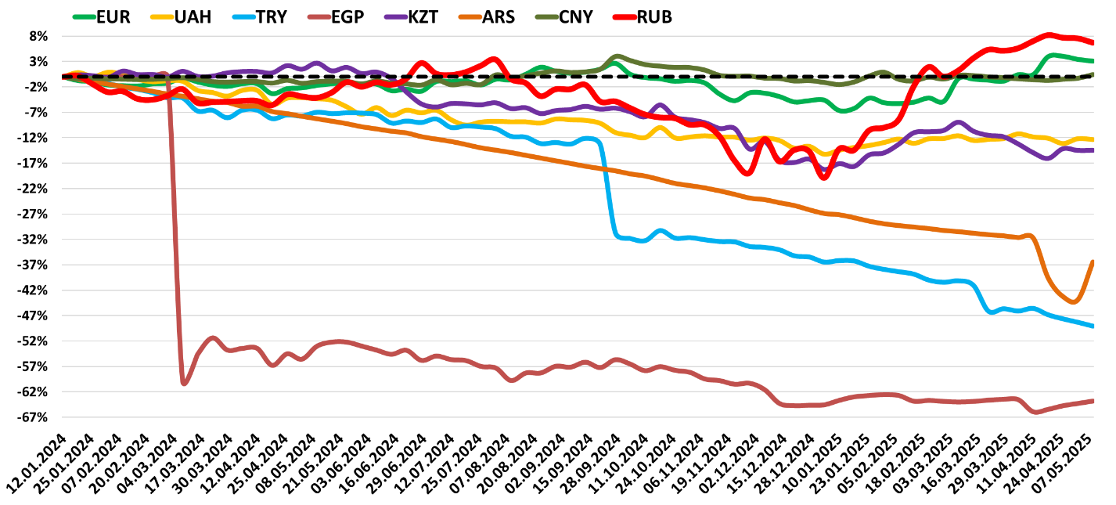

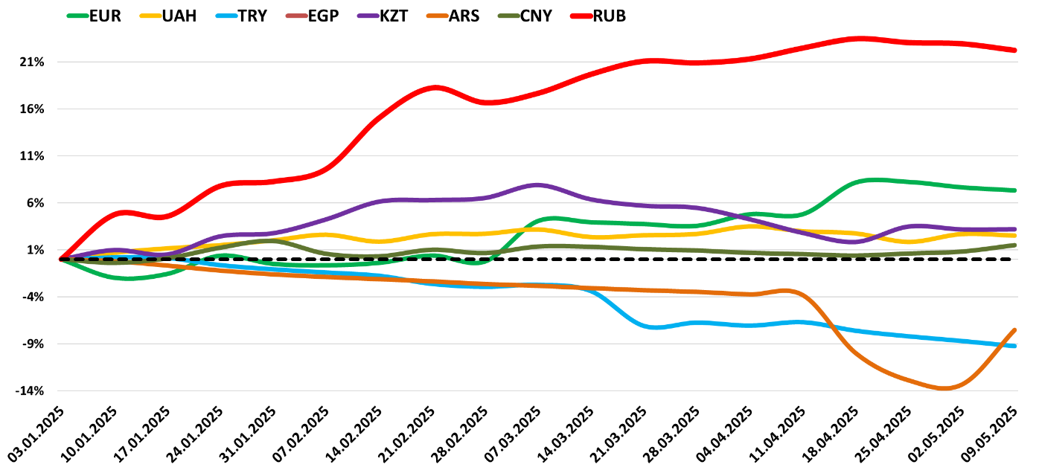

Hot topic 5. The dynamics of 3 weekly export duties, RUR/ton…

The weekly dynamics of Moscow “exchange”’ 3 grains price indexes for determining export duties, $/ton
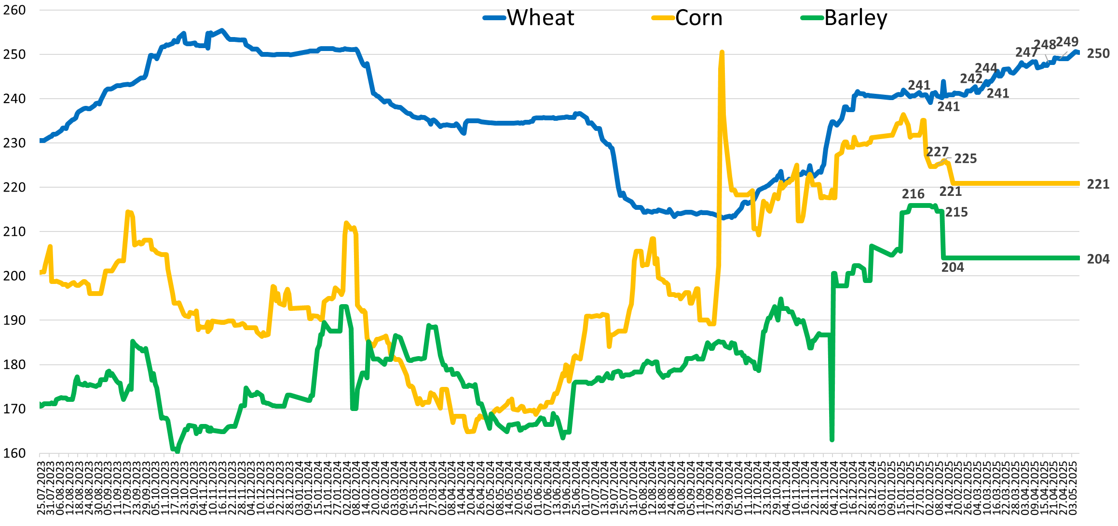

The dynamics of 3 weekly export duties, RUR/ton…
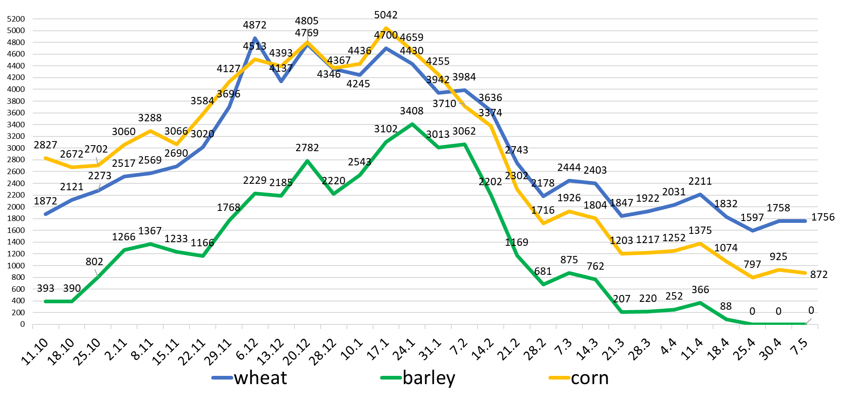

The dynamics of 3 weekly export duties, $/ton
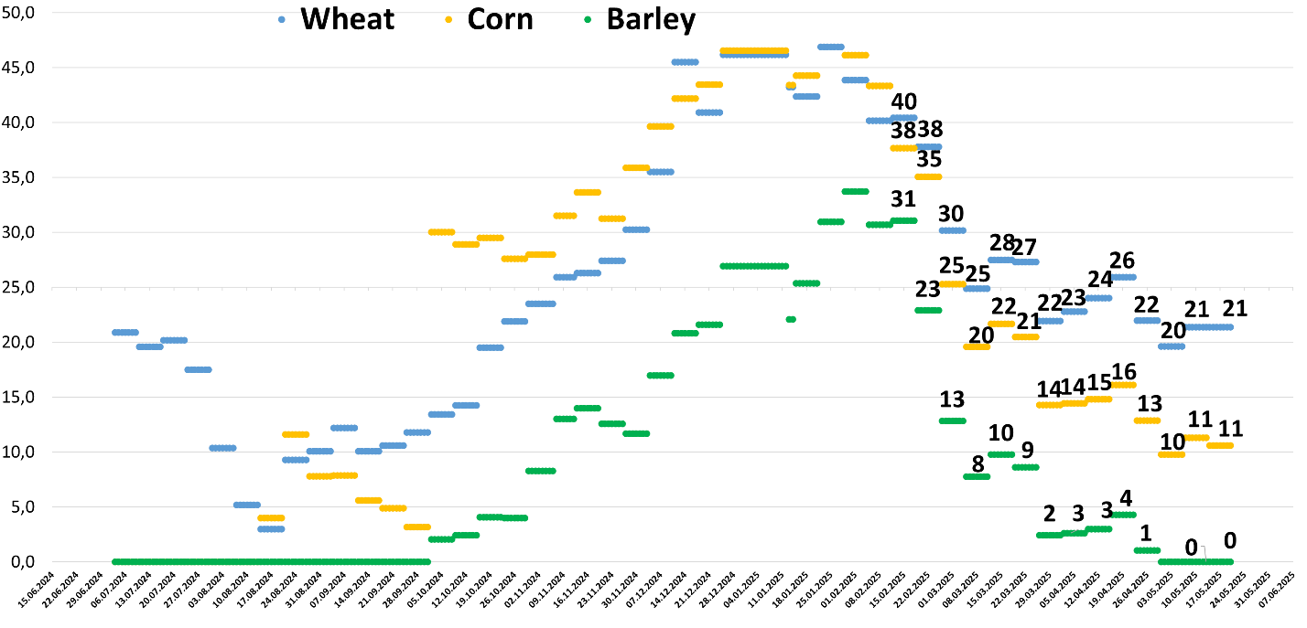

Hot topic 6. Grain price indexes

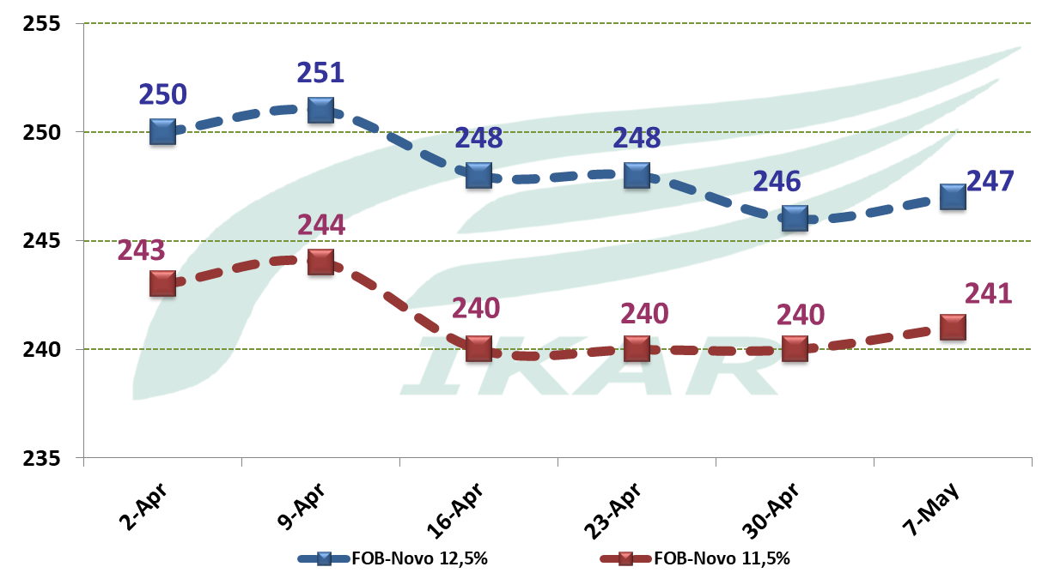
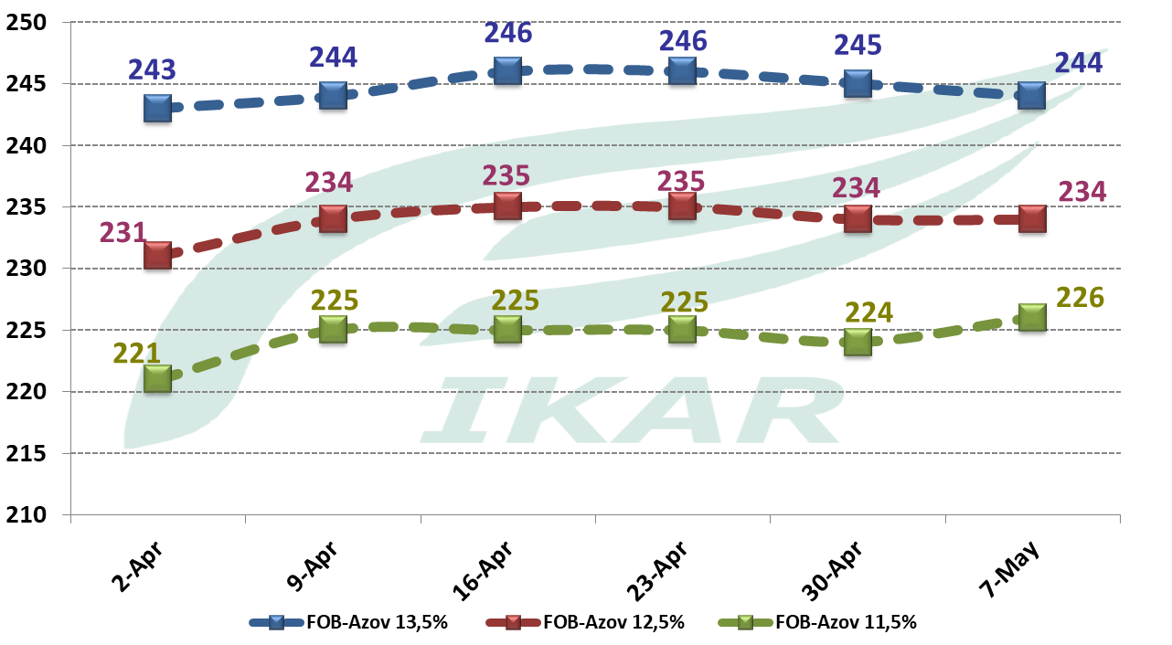

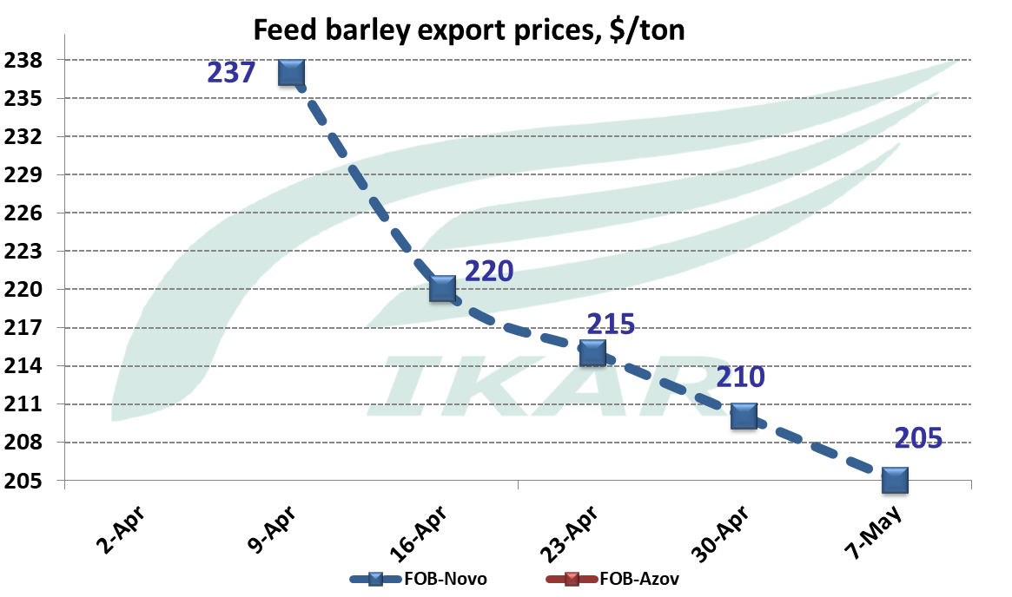
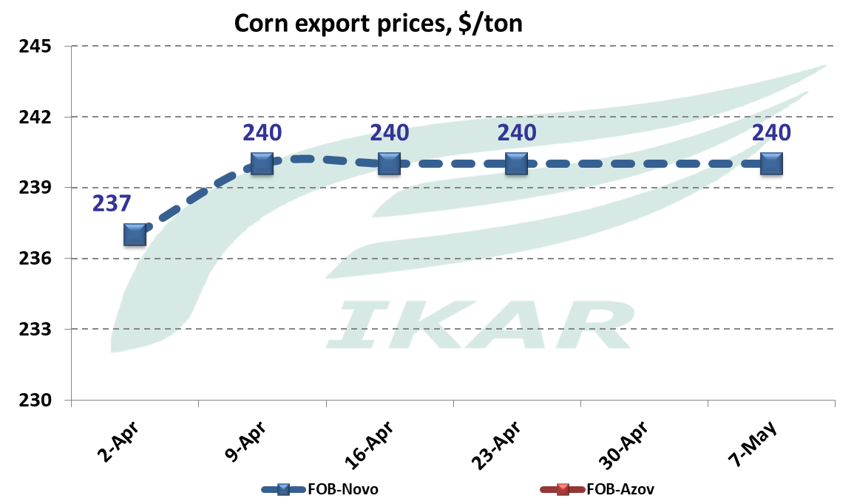

Central Black Soil processors purchasing price indexes, RUR/ton

Wheat
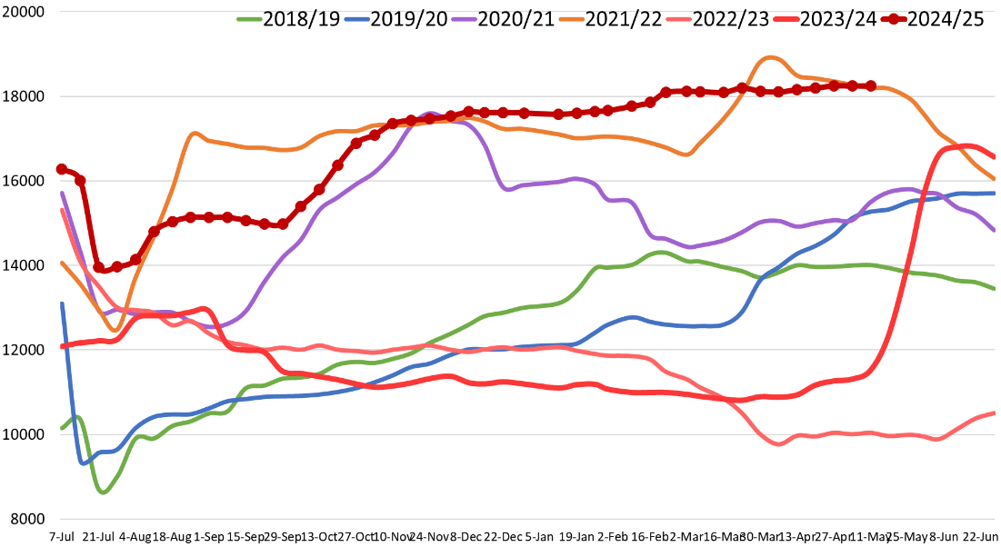

Barley
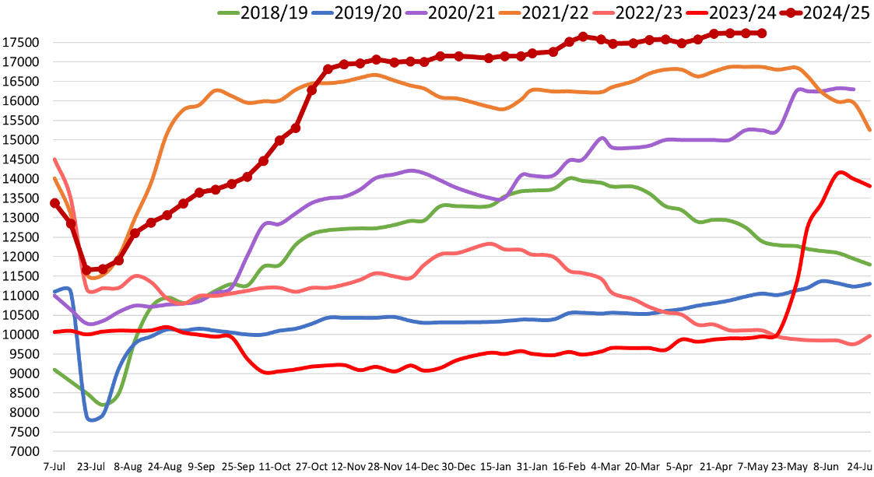

Corn
